Build instructions
MK-312-BTχ

September 2022

General

You will need:
- A soldering iron with a fine tip
- Solder
- Sidecutters
- Small long-nose pliers
- A 1.5 mm hex key (aka "Alan key")

Optional:
- Desoldering braid
- Bending aid for the resistors and diodes
- General household glue

Electrostatic devices are marked with bold purple text in the document. Be careful when handling them and if possibe use an antistatic mat and/or wrist strap.

Make sure you have display-components.pdf and mainboard-components.pdf ready on your screen or printed out. This will save you a lot of time looking up component values.

Display print

Preparations
The shafts of the potentiometers are a bit too long; if you have the tools, cut off 5 mm of the shafts so the knobs will hide the nuts that hold the frontpanel in place.
The printing on the frontpanel is standard silkscreen ink used for PCBs; this is probably not resistant against a lot of wear and fingerprints, so you might consider coating it with clear varnish.
The sides of the round ‘LCD’ and ‘VDC’ holes in the frontpanel will remain visible; if that bothers you, use a permanent marker to blacken the sides.

Building
First clean the board with isopropyl alcohol. Start with the IDC pin header on the back of the PCB (this is the only component on the back). The pins will sit under the LCD and it should fit, but check anyway. Watch out for solder spikes and remove then.
Continue with the resistors, capacitor, IC socket and small trimmer pot. Mount the transistors close to the PCB, but not directly on it; the holes for soldering are very small so watch out for solder bridges.
Next, mount the push buttons, but solder only one leg first! The flat side of the button should point to the top or the bottom. Put the caps on the buttons. Solder the 16 pin header with one pin only, too.
On the large potentiomers there is a small nub; this is normally used for anti-rotation but it interferes with the front panel; remove it with side cutters or small pliers.
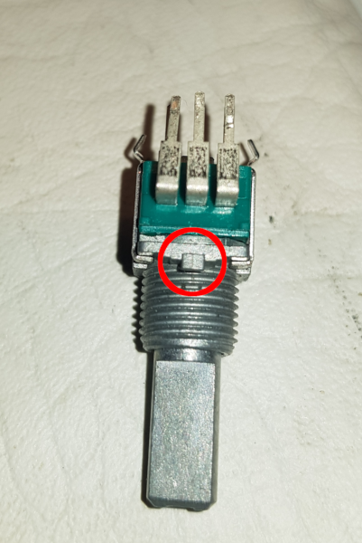
Solder the potientometers on the PCB, make sure they are lined up correctly; use the front panel as a guide.
Now comes the fiddly bit. Drop in the LEDs through the holes, but don’t solder them. Do the same with the LCD, placing it over the pin header but do not solder. Mount the frontpanel over the 3 potentiometers with washers and nuts; put in the 2.5 mm bolts and tighten the nuts very loosely; use the extra nuts to align the LCD with the frontpanel on the left hand side.
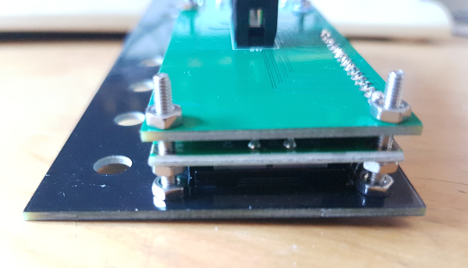
Check if the boards are not warped or bent, and everything is flush with the frontpanel. The buttons and LCD should stick out only a very small amount (~1 mm).
Now solder the other legs of the push buttons, make sure they don’t rub against the sides of the front panel. Solder the rest of the pin header for the LCD.
Now it’s time for the LEDs. Decide how high you want to mount them, e.g. let them stick through the front panel or slightly recessed.
Remove the frontpanel, solder the LCD to the pin header and mount the 4066 IC in its socket. Mount the frontpanel again, put the bolts back in and secure the nuts with a bit of glue.

Mainboard
The assembly of the mainboard is pretty straightforward. Clean the board with isopropyl alcohol. Start with the diodes, resistors and small capacitors; be gentle with the 1N4148 diodes with their glass housing. Raise R30 (0.5 Watt resistor) a bit above the board, in case it gets hot. Install the crystal.
Then add the electrolytic capacitors (check polarity!), power bus connector, on/off switch, F1 polyfuse and the power regulators (LM2914, 7809 and 7805). Check for shorts and inspect your soldering so far; if all is okay, apply about 16 Volt to the power input (positive center tap); the voltage on J1 (battery connector) should be about 13.7 Volt, the charging voltage. Check the voltages of the other regulators.
You can connect the battery usig the ‘Deans’ T-shaped power connector situated between C4 and C5; it allows you to quickly swap batteries. However, you can also wire it directly to the holes below R1 and R2.
Some people don’t like to put ICs in sockets, however it is recommended to put in sockets for at least U1 (microcontroller), U9 (MAX232, external interface) and U8 (LTC1661). These components are the most likely to be damaged or are otherwise very difficult to replace. If you don’t care, put in all the IC sockets.
Now come the pin headers. There is one 6 pin female header for the radio interface and there should be a 16 pin male header that you have to break up in smaller pieces. Depending on your wishes you may not have to install any of them:
- JP2 is only needed if you want a different audio input (for example RCA jacks).
- JP6 and JP7 are only needed if you want tri-polar output (not to be confused with the firmware’s "tri-phase"). For this you must have the apropriate toys with 3 electrically separated sections; you must always use stereo jacks when you put a jumper on JP6 or JP7, as using a mono jack will short half of the output transformer.
- J9 is the female 6 pin header; you can plug in a BlueTooth receiver in here but this is entirely optional.
- J12 is a 2x3 header for programming the microcontroller, if you’re into that sort of thing.
- Finally, there are two 2-pin headers labelled ‘+5V’ and ‘+12V’ near the voltage regulators; they can be used to tap of 5 resp. 12 Volt for external circuits.
Continue with J11 (24 pin header) and the 3.5 mm jacks.
Then the transformers; the board has options for 2 different transformers: the small 42TL004 or the more powerful 42TU200. The holes in the board are spaced for the larger TU200, so carefully bend the wires of the TL004 outward in a zig-zag:
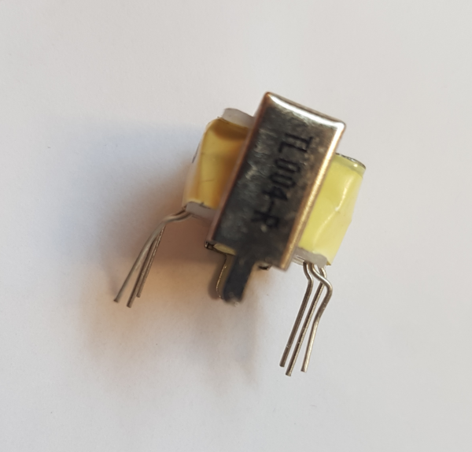
Note the location of the primary side! Solder the lugs of the transformer housing to the PCB.
Note that if you do install the 42TU200s you must also have the correct value for R30 (0.27 Ohm).
Finally, install the MOSFETs. Check your soldering and voltages again, then put the ICs in their sockets; note that the 40 pin ATMega16 requires quite a bit of force, push it all the way down! Connect the display to the mainboard with the flatcable. Now comes the moment of truth....
Connect the battery or an external power supply, flick the switch and when everything goes according to plan, you should be greeted with a version number and a self-test message on the display. You may have to tune the LCD contrast by adjusting the trimmer on the display print with a small screwdriver.

